# Topic: TO Supply Left Over Food To Poor

Team members:

1.karthikeyan R

2.Josephraymond W

3.Palanivelrajan T

4.Ragul A

# Introduction

The problem of **food waste** exists globally, often in stark contrast to the persistent issue of **food insecurity** and **poverty**. In many communities, edible and nutritious food is discarded daily by restaurants, caterers, events, and even households, while a significant portion of the population goes hungry.

* **Problem Statement:** The massive scale of food waste coexists with widespread hunger, indicating a critical gap in the food distribution system.
* **Goal:** To establish an efficient, hygienic, and scalable system to **rescue surplus, edible food** and redistribute it to those in need, specifically the poor and vulnerable populations.
* **Significance:** This project addresses two major problems simultaneously: reducing environmental burden from food waste and alleviating hunger, promoting social equity and sustainability.

## Abstract

* This project, **"Food Rescue and Redistribution (FRR),"** proposes a systematic, technology-enabled solution to bridge the gap between food surplus and food scarcity. It involves **partnering with food donors** (e.g., hotels, bakeries, corporate cafeterias), establishing a **logistically sound collection and transportation network**, and directly supplying the collected, safe, leftover food to registered **charitable organizations, shelters, or direct distribution points** serving the poor. The core functionality relies on a dedicated app or platform for real-time donor-recipient coordination, ensuring food safety compliance and maximizing efficiency. The expected outcome is a significant reduction in local food waste and a direct, measurable impact on reducing hunger among the underprivileged.

# Creating Developer Account

Creating a developer org in salesforce**.**

1. **Go to**[**https://developer.salesforce.com/signup**](https://developer.salesforce.com/signup)
2. **On the sign up form, enter the following details : [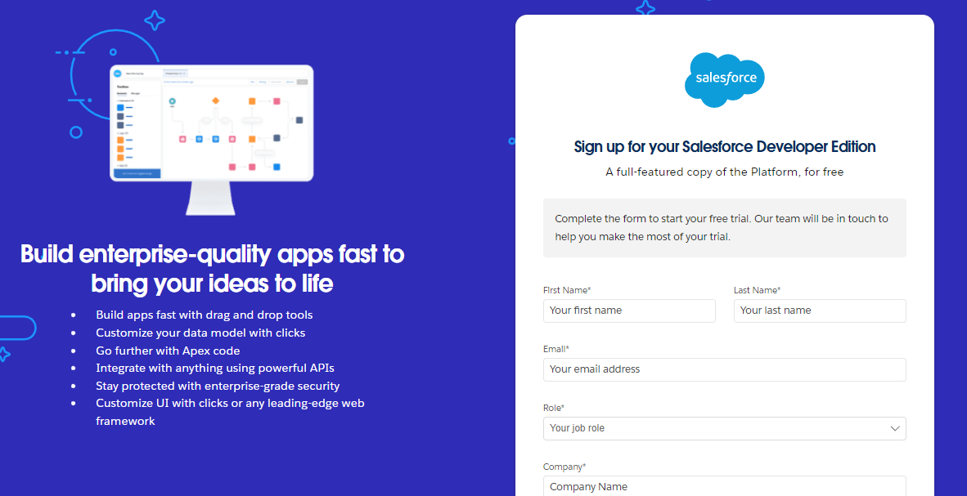](https://developers.salesforce.com/Signup*)**
   1. **First name & Last name**
   2. **Email**
   3. **Role : Developer**
   4. **Company : College or Company Name**
   5. **County : India**
   6. **Postal Code : pin code**
   7. **Username : should be a combination of your name and company**

**This need not be an actual email id, you can give anything in the format :**

**username@organization.com**

**Click on sign me up after filling these.**

**Account Created:**

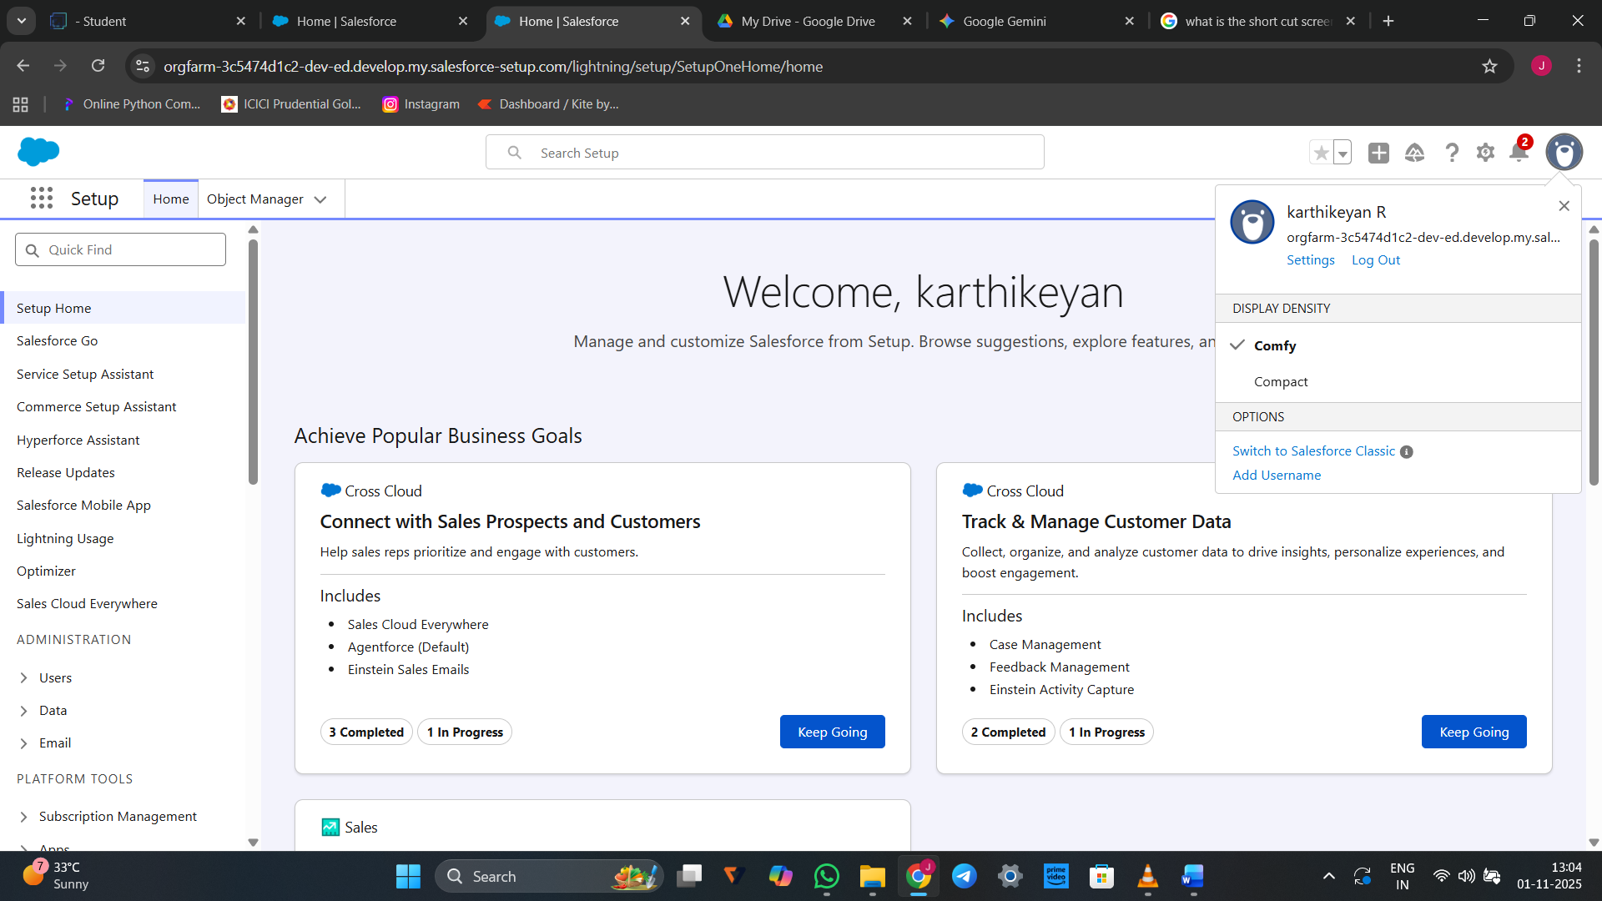

**Create an object:**

## Create Venue Object:

## Create an object:

1. **From the setup page >> Click on Object Manager >> Click on Create >>Click on Custom Object.**
2. **Enter the label name >> Venue**
3. **Plural label name >> Venues**
4. **Enter Record Name Label and Format**

* **Record Name >> Venue Name**
* **Data Type >> Text**

1. **Click on Allow reports and Track Field History,Allow Activities.**
2. **Allow search >> Save.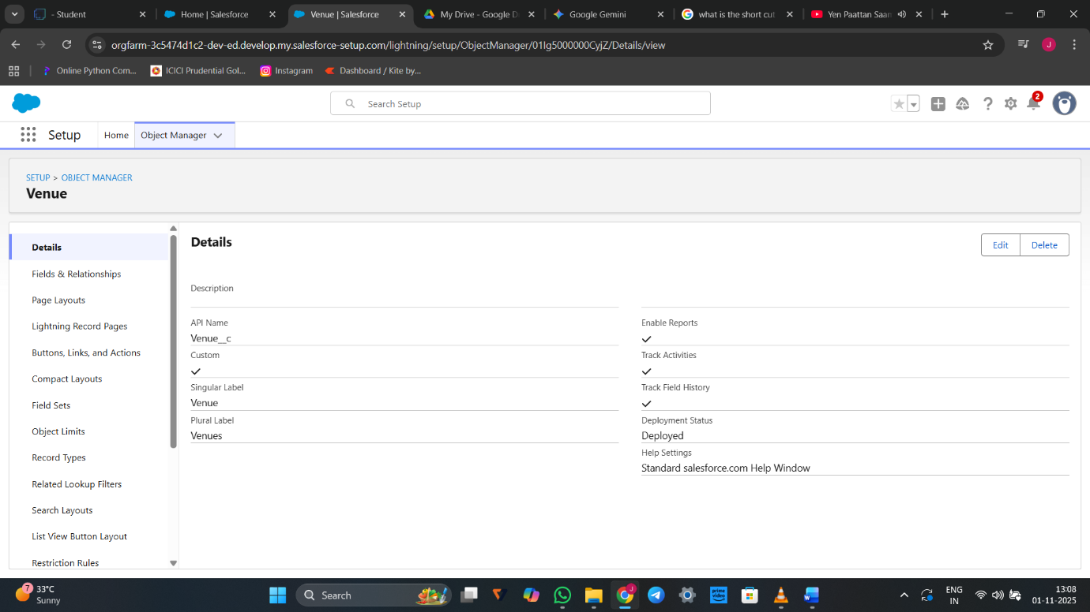**Create Drop-Off Point Object

## To create an object:

1. **From the setup page >> Click on Object Manager >> Click on Create >> Click on Custom Object.**
2. **Enter the label name >> Drop-Off Point**
3. **Plural label name>> Drop-Off Points**
4. **Enter Record Name Label and Format**

* **Record Name >> Drop-Off point Name**
* **Data Type >> Text**

1. **Click on Allow reports and Track Field History,Allow Activities**
2. **Allow search >> Save.**

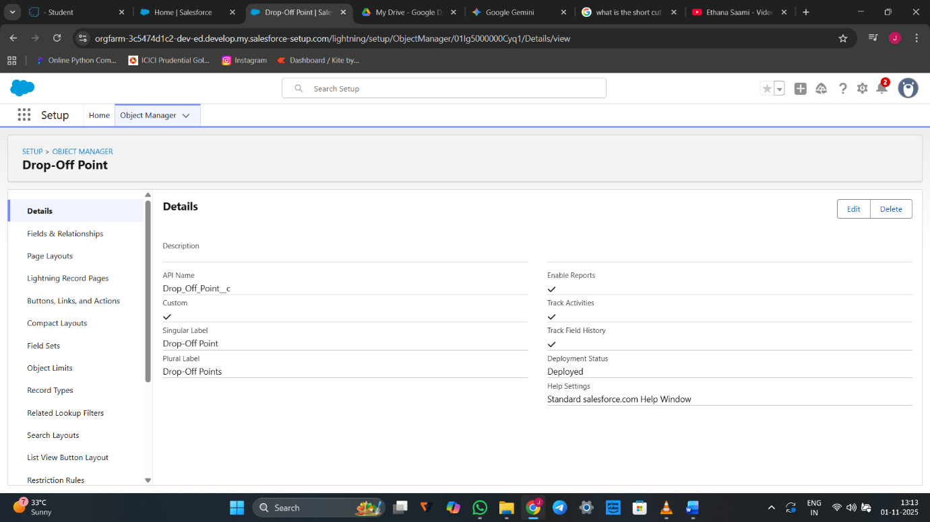**Drop-off point created**

# To create an object:

1. **From the setup page >> Click on Object Manager >> Click on Create >> Click on Custom Object.**
2. **Enter the label name>> Task**
3. **Plural label name>> Tasks**
4. **Enter Record Name Label and Format**

* **Record Name >> Task Name**
* **Data Type >> Text**

1. **Click on Allow reports and Track Field History,Allow Activities**
2. **Allow search >> Save.**

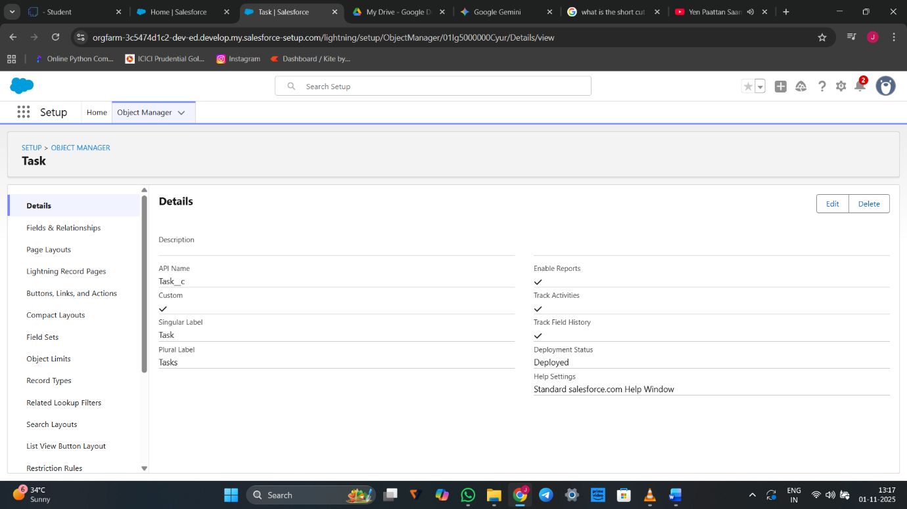

# Create Volunteer Object

## To create an object:

1. **From the setup page >> Click on Object Manager>> Click on Create >> Click on Custom Object.**
2. **Enter the label name>> Volunteer**
3. **Plural label name>> Volunteers**
4. **Enter Record Name Label and Format**

* **Record Name >> Volunteer Name**
* **Data Type >> Text**

**4.Click on Allow reports and Track Field History, Allow Activities**

**5.Allow search >> Save.**

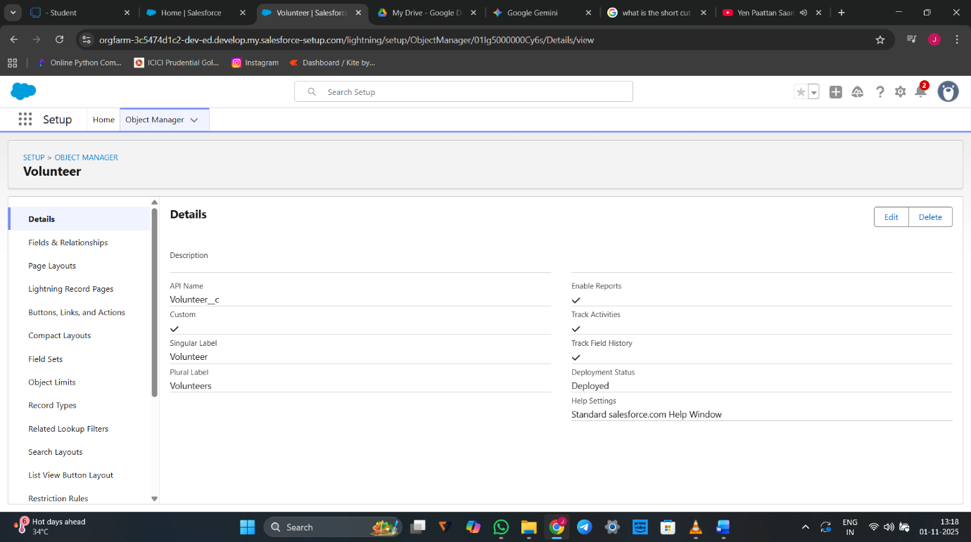

## Create Execution Details Object

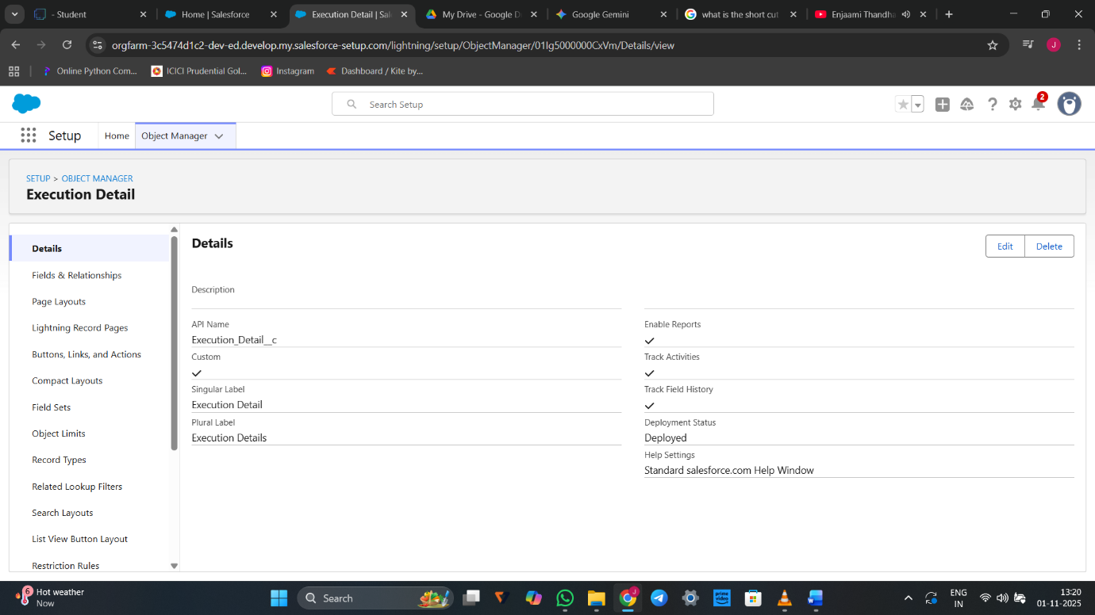

# Creating a Custom Tab

## To create a Tab:(Venue)

1. **Go to setup page >> type Tabs in Quick Find bar >> click on tabs >> New (under custom object tab)**

2. Select Object(Venue) >> Select the tab style >> Next (Add to profiles page) keep it as default >> Next (Add to Custom App) uncheck the include tab .

3. Make sure that the Append tab to users' existing personal customizations is checked.

4. Click save.

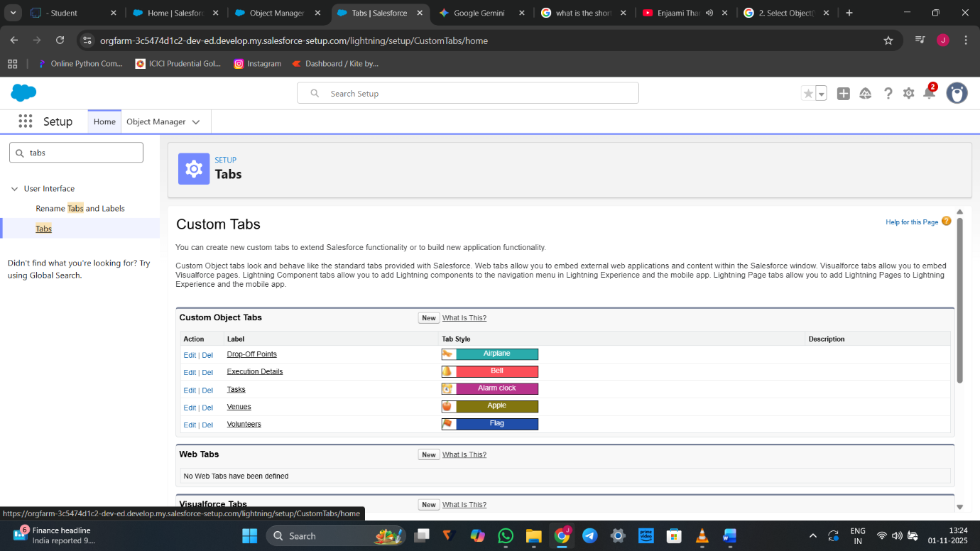

# Create a Lightning App

## To create a lightning app page:

1. Go to setup page >> search “app manager” in quick find >> select “app manager” >> click on New lightning App.
2. 2. Fill the app name in app details and branding as follow  
   App Name : FoodConnect  
   Developer Name : This will auto populated  
   Image : optional (if you want to give any image you can otherwise not mandatory) Primary color hex value : keep this default.
3. 3.Then click Next  >> (App option page)Set Navigation Style as Standard Navigation >> Next.

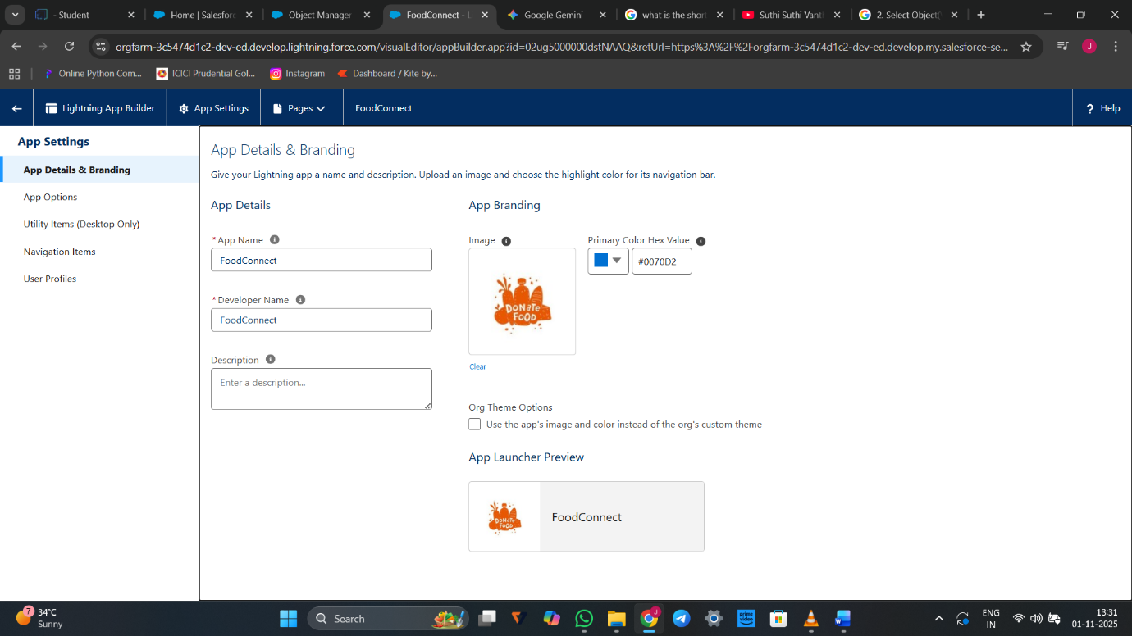

**Creation of Relationship fields in objects:**

### Creation of Lookup Relationship Field on Volunteer Object :

1. Go to setup >> click on Object Manager >> type object name(Volunteer) in the search  bar >> click on the object.
2. Now click on “Fields & Relationships” >> New
3. Select Master Detail relationship
4. Select the related object “Drop-Off point” and click next.
5. Field Name : Drop_Off_point
6. Field label : Auto generated
7. Next >> Next >> Save.

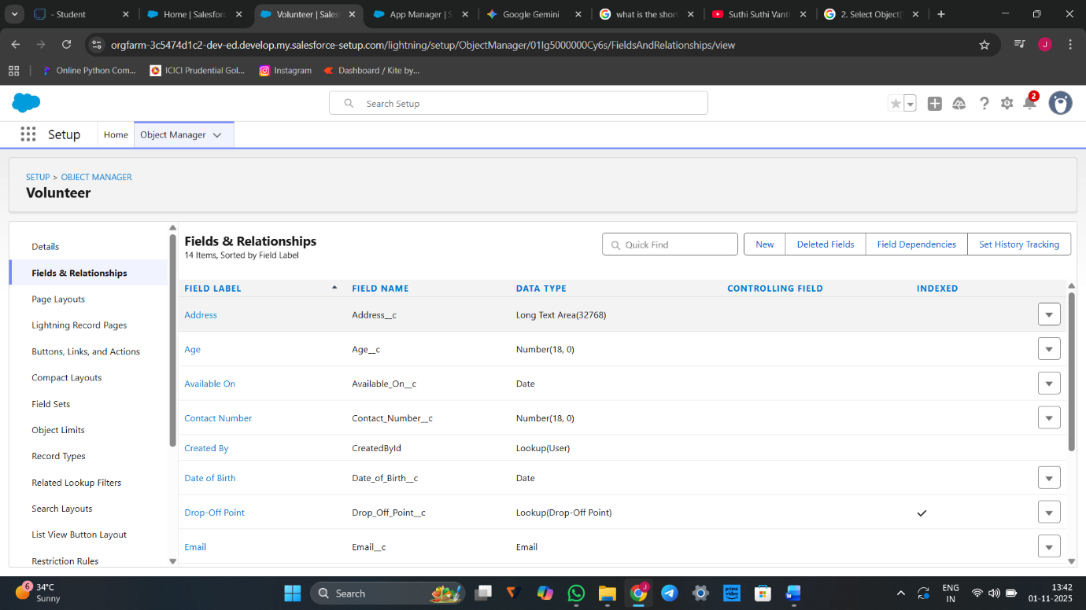

### Creation of Master Detail Relationship Field on Execution Details Object :

1. Go to setup >> click on Object Manager >> type object name(Execution Details) in the search  bar >> click on the object.
2. Now click on “Fields & Relationships” >> New
3. Select Master Detail relationship
4. Select the related object “Volunteer” and click next.
5. Field Name : Volunteer
6. Field label : Auto generated
7. Next >> Next >> Save.

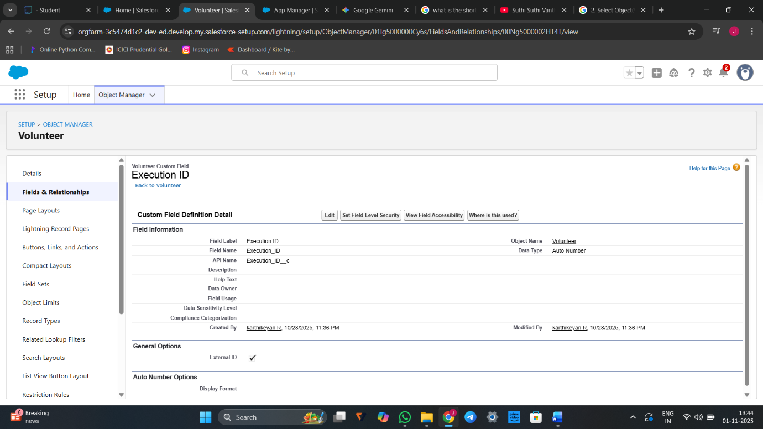

### Creation of Master Detail Relationship Field on Execution Details Object :

1. Go to setup >> click on Object Manager >> type object name(Execution Details) in the search  bar >> click on the object.
2. Now click on “Fields & Relationships” >> New
3. Select Master Detail relationship
4. Select the related object “Task” and click next.
5. Field Name : Task
6. Field label : Auto generated
7. Next >> Next >> Save.

## Creation of Lookup Relationship Field on Drop-Off Point Object :

1. Go to setup >> click on Object Manager >> type object name(Drop-Off Point) in the search  bar >> click on the object.
2. Now click on “Fields & Relationships” >> New
3. Select Lookup relationship
4. Select the related object “Venue” and click next.
5. Field Name : Venue
6. Field label : Venue__c
7. Next >> Next >> Save.

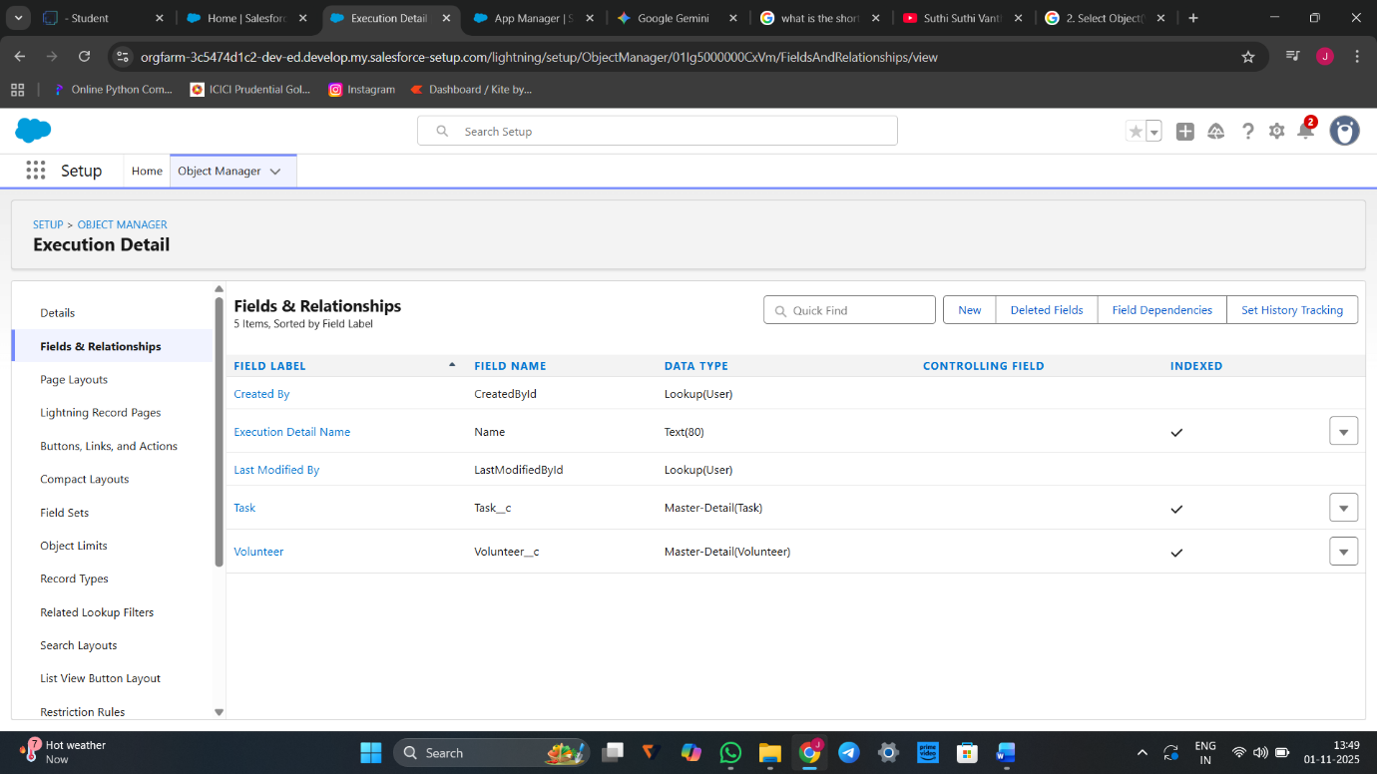

## Creation of fields for the Venue object

1. Go to setup>> click on Object Manager >> type object name(Venue) in search bar >> click on the object.
2. Now click on “Fields & Relationships” >> New
3. Select Data type as a “Email” and Click on Next
4. Fill the Above as following:

* Field Label : Contact Email
* Field Name : Contact Email
* Click on required check box
* Click on Next >> Next >> Save and new

## To create another fields in an object:

1. Go to setup >> click on Object Manager >> type object name(Venue) in search bar >> click on the object.
2. Now click on “Fields & Relationships” >> New
3. Select Data type as a “Phone” and Click on Next
4. Fill the Above as following:

* Field Label : Contact Phone
* Field Name : Contact Phone
* Click on required check box
* Click on Next >> Next >> Save and new.

## 

## To create another fields in an object:

1. Go to setup >> click on Object Manager >> type object name(Venue) in search bar >>click on the object.
2. Now click on “Fields & Relationships” >> New
3. Select Data type as a “Geolocation” and Click on Next
4. Fill the Above as following:

* Field Label : Location
* Decimal Places : 4
* Field Name : Location
* Description : Enter the Geolocation of your Venue
* Click on Next >> Next >> Save and new.

## To create another fields in an object:

8.Go to setup >> click on Object Manager >> type object name(Venue) in search bar >> click on the object.

1. Now click on “Fields & Relationships” >> New
2. Select Data type as a “Long Text Area” and Click on Next
3. Fill the Above as following:

* Field Label : Venue Location
* Field Name : Venue_Location
* Click on Next >> Next >> Save and new.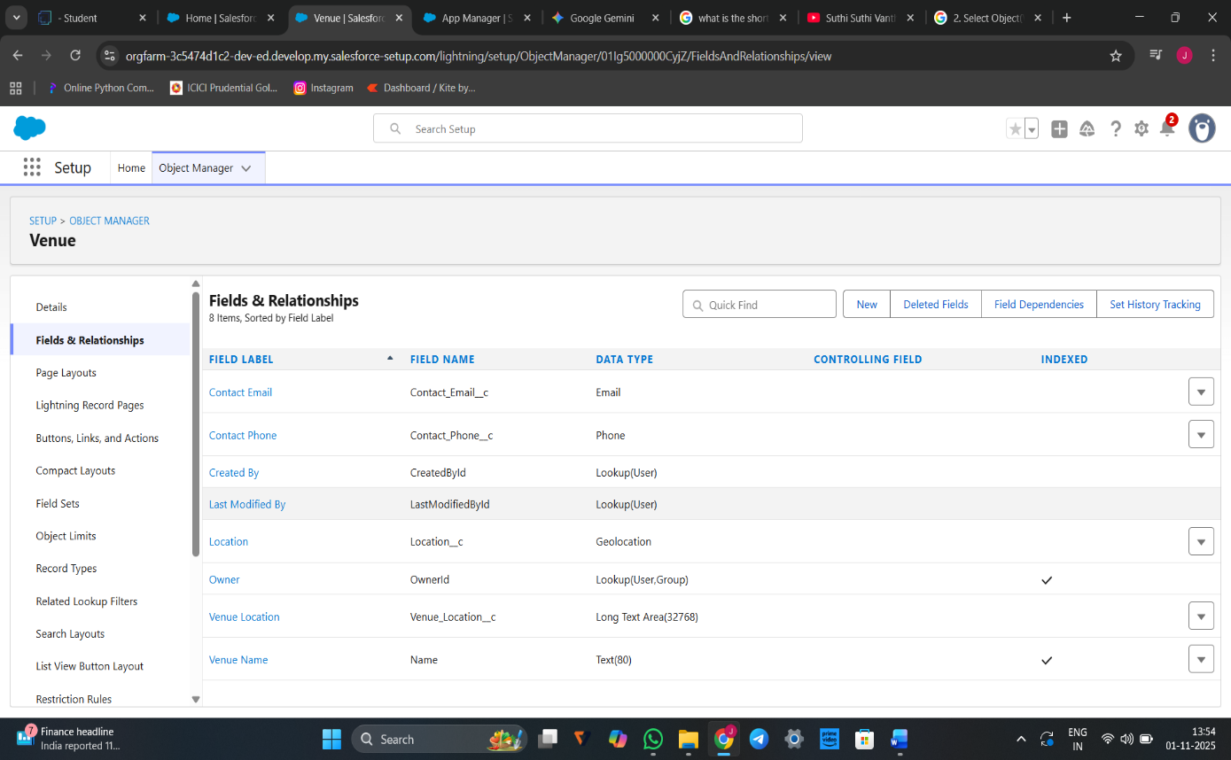

# Creation of fields for the Drop-Off point object

1.Go to setup >> click on Object Manager >> type object name(Drop-Off point) in search bar >> click on the object.

2. Now click on “Fields & Relationships” >> New

3. Select Data type as a “Geolocation” and Click on Next

4. Fill the Above as following:

* Field Label : Location 2
* Field Name : gets auto generated
* Description : Enter the Geolocation of the Drop off Point
* Geolocation Options : select Decimal
* Decimal Places : 4
* Click on Next >> Next >> Save and new.

## To create another fields in an object:

1. Go to setup >> click on Object Manager >> type object name(Drop-Off point) in search bar >> click on the object.
2. Now click on “Fields & Relationships” >> New
3. Select Data type as a “Formula” and Click on Next
4. Fill the Above as following:

* Field Label : distance calculation
* Field Name : distance_calculation
* Formula Return Type : Number
* Formula Options : DISTANCE( Location_2__c ,  Venue__r.Location__c , 'km')
* Click on Next >> Next >> Save and new.

## To create another fields in an object:

1. Go to setup >> click on Object Manager >> type object name(Drop-Off point) in search bar >> click on the object.
2. Now click on “Fields & Relationships” >> New
3. Select Data type as a “Picklist” and Click on Next
4. Fill the Above as following:

* Field Label : State
* Field Name : State
* Enter values, with each value separated by a new line :

Andhra Pradesh

Arunachal Pradesh

Assam

Bihar

Chhattisgarh

Goa

Gujarat

Haryana

Himachal Pradesh

Jharkhand

Karnataka

Kerala

Maharashtra

Madhya Pradesh

Manipur

Meghalaya

Mizoram

Nagaland

Odisha

Punjab

Rajasthan

Sikkim

Tamil Nadu

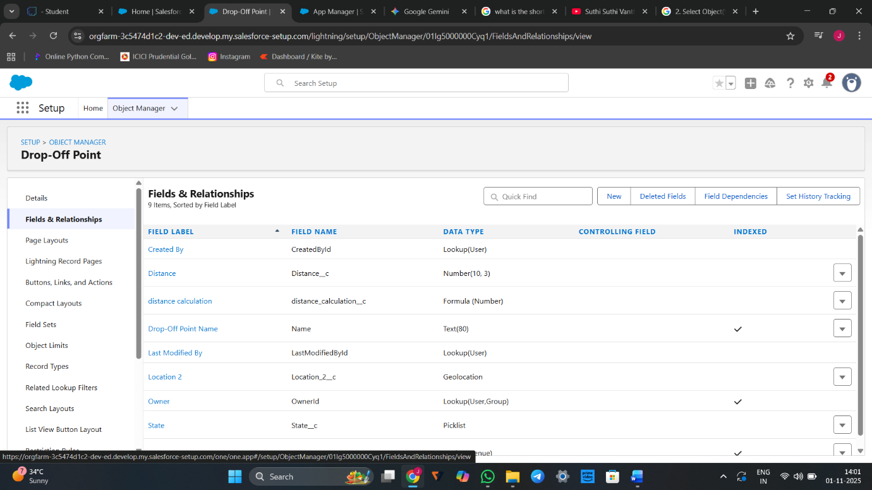

# Creation of fields for the Task object

1.Go to setup>> click on Object Manager >> type object name(Task) in search bar >> click on the object.

2. Now click on “Fields & Relationships” >> New

3. Select Data type as a “Auto Number” and Click on Next

4. Fill the Above as following:

* Field Label : Task ID
* Display Format : TASK-{0}
* Starting Number : 1
* Field Name : gets auto generated
* Click on required check box
* Click on Next >> Next >> Save and new.

## 

## To create another fields in an object:

1. Go to setup >> click on Object Manager >> type object name(Task) in search bar >> click on the object.
2. Now click on “Fields & Relationships” >> New
3. Select Data type as a “Date” and Click on Next
4. Fill the Above as following:

* Field Label : Date
* Field Name : Date
* Click on required check box
* Click on Next >> Next >> Save and new.

## 

## To create another fields in an object:

1. Go to setup >> click on Object Manager >> type object name(Task) in search bar >> click on the object.
2. Now click on “Fields & Relationships” >> New
3. Select Data type as a “Picklist (Multi-Select)” and Click on Next
4. Fill the Above as following:

* Field Label : Food Category
* Field Name : Food Category
* Enter values, with each value separated by a new line :

Veg

Non-Veg

Salad

Snack

* Click on required check box
* Click on Next >> Next >> Save and new.

## To create another fields in an object:

1. Go to setup >> click on Object Manager >> type object name(Task) in search bar >> click on the object.
2. Now click on “Fields & Relationships” >> New
3. Select Data type as a “Number” and Click on Next
4. Fill the Above as following:

* Field Label : Number of People Served
* Field Name : Number_of_People_Served
* Click on required check box
* Click on Next >> Next >> Save and new.

## To create another fields in an object:

1. Go to setup >> click on Object Manager >> type object name(Task) in search bar >> click on the object.
2. Now click on “Fields & Relationships” >> New
3. Select Data type as a “Text” and Click on Next
4. Fill the Above as following:

* Field Label : Name of the Person
* Field Name : Name_of_the_Person
* Click on Next >> Next >> Save and new.

## To create another fields in an object:

1. Go to setup>> click on Object Manager >> type object name(Task) in search bar >> click on the object.
2. Now click on “Fields & Relationships” >> New
3. Select Data type as a “Phone” and Click on Next
4. Fill the Above as following:

* Field Label : Phone
* Field Name : Phone
* Click on Next >> Next>> Save and new.

## To create another fields in an object:

1. Go to setup >> click on Object Manager >> type object name(Task) in search bar >> click on the object.
2. Now click on “Fields & Relationships” >> New
3. Select Data type as a “Pick List” and Click on Next
4. Fill the Above as following:

* Field Label : Rating
* Field Name : Rating
* Enter values, with each value separated by a new line :
* Click on Next >> Next >> Save and new.

## To create another fields in an object:

1. Go to setup >> click on Object Manager >> type object name(Task) in search bar >> click on the object.
2. Now click on “Fields & Relationships” >> New
3. Select Data type as a “Long Text Area” and Click on Next
4. Fill the Above as following:

* Field Label : Feedback
* Field Name : Feedback
* Click on Next >> Next >> Save and new.

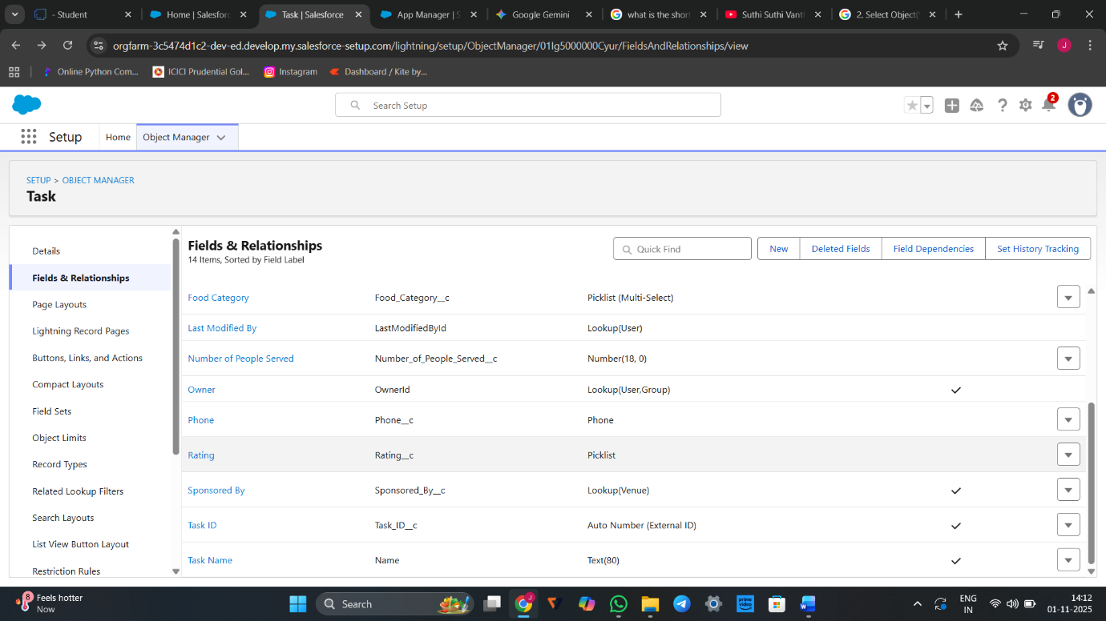

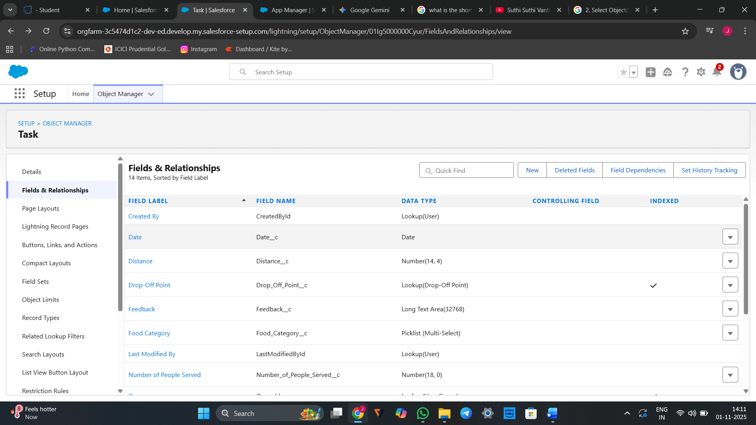Creation of fields for the Volunteer object

1. Go to setup >> click on Object Manager >> type object name(Volunteer) in search bar >> click on the object.

2. Now click on “Fields & Relationships” >> New

3. Select Data type as a “Auto Number” and Click on Next

4. Fill the Above as following:

* Field Label : Volunteer ID
* Field Name : gets auto generated
* Click on required check box
* Click on Next >> Next >> Save and new.
* Click on Next >> Next >> Save and new.

## To create another fields in an object:

1. Go to setup >> click on Object Manager >> type object name(Volunteer) in search bar >> click on the object.
2. Now click on “Fields & Relationships” >> New
3. Select Data type as a “Picklist” and Click on Next
4. Fill the Above as following:

* Field Label : Gender
* Field Name : Gender
* Enter values, with each value separated by a new line :

Female

Male

* Click on Next >> Next >> Save and new.

## To create another fields in an object:

1. Go to setup >> click on Object Manager >> type object name(Volunteer) in search bar >> click on the object.
2. Now click on “Fields & Relationships” >> New
3. Select Data type as a “Date” and Click on Next
4. Fill the Above as following:

* Field Label : Available On
* Field Name : Available On
* Click on required check box
* Click on Next >> Next >> Save and new.

## To create another fields in an object:

1. Go to setup >> click on Object Manager >> type object name(Volunteer) in search bar >> click on the object.
2. Now click on “Fields & Relationships” >> New
3. Select Data type as a “Number” and Click on Next
4. Fill the Above as following:

* Field Label : Age
* Field Name : Age
* Click on required check box
* Click on Next >> Next>> Save and new.

## To create another fields in an object:

1. Go to setup >> click on Object Manager >> type object name(Volunteer) in search bar >> click on the object.
2. Now click on “Fields & Relationships” >> New
3. Select Data type as a “Email” and Click on Next
4. Fill the Above as following:

* Field Label : Email
* Field Name : Email
* Click on required check box
* Click on Next>> Next >> Save and new.

## To create another fields in an object:

1. Go to setup >> click on Object Manager >> type object name(Volunteer) in search bar >> click on the object.
2. Now click on “Fields & Relationships” >> New
3. Select Data type as a “Number” and Click on Next
4. Fill the Above as following:

* Field Label : Contact Number
* Field Name : Contact_Number
* Click on required check box
* Click on Next >> Next >> Save and new.

## To create another fields in an object:

1. Go to setup >> click on Object Manager >> type object name(Volunteer) in search bar >> click on the object.
2. Now click on “Fields & Relationships” >> New
3. Select Data type as a “Text Area (Long)” and Click on Next
4. Fill the Above as following:

* Field Label : Address
* Field Name : Address
* Click on Next >> Next >> Save and new.

## To create another fields in an object:

1. Go to setup >> click on Object Manager >> type object name(Volunteer) in search bar >> click on the object.
2. Now click on “Fields & Relationships” >> New
3. Select Data type as a “Date” and Click on Next
4. Fill the Above as following:

* Field Label : Date of Birth
* Field Name : Date_of_Birth
* Click on Next >> Next >> Save and new.

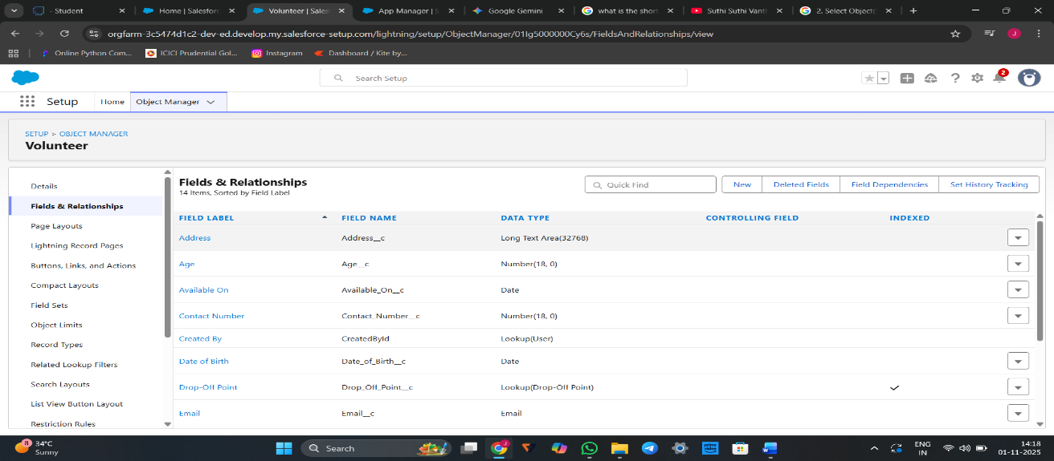

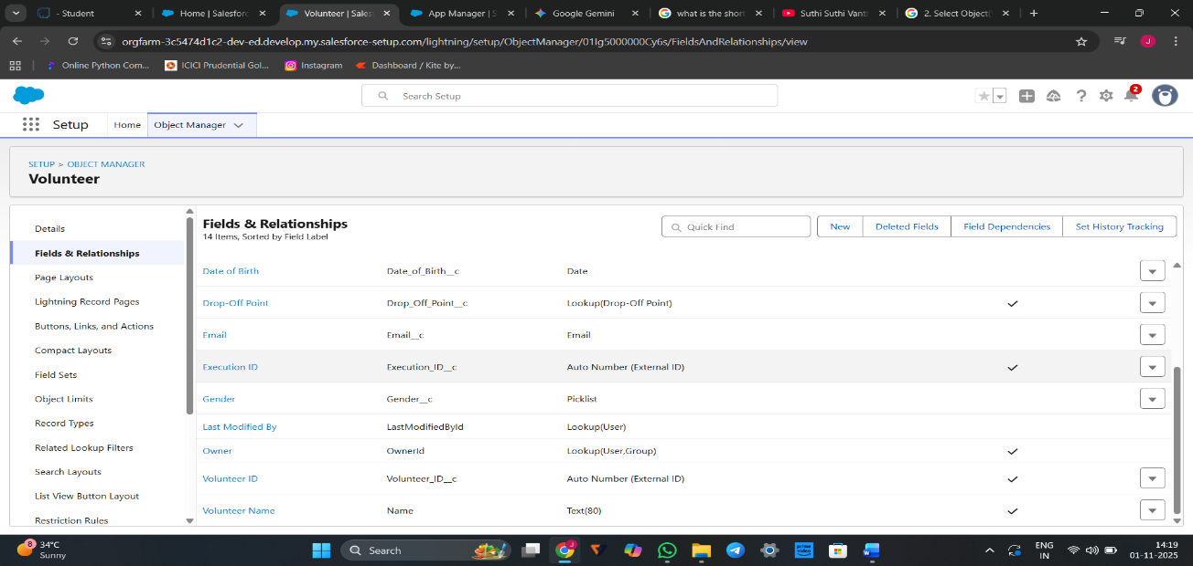

Create Flow to create a record in Venue object

1. Go to setup >> type Flow in quick find box >> Click on the Flow and Select the New Flow.
2. Select the Screen flow. Click on create.Click on the ‘+’ icon in between start and end, and click on screen element.
3. Under the Screen Properties:

Label : Venue Details

API Name : Venue_Details

1. Now lets add components in this flow. Click on Text Component and name it as:

Label : Venue Name

API Name : Venue_Name

1. Click on Email Component and name it as:

Label : Email

API Name : Contact_Email

1. Click on Phone Component and name it as:

Label : Phone

API Name : Contact_Phone

1. Click on Text Component and name it as:

Label : Venue Location

API Name : Venue_Location

1. Click on Number Component and name it as:

Label : Latitude

API Name : Latitude

1. Click on Number Component and name it as:

Label : longitude

API Name : longitude

1. Next click on Done.
2. Click on the ‘+’ icon in between Venue details and end, and click on create record element.
3. Now label it as

Label : Create Venue Record

API Name : Create_Venue_Record

How Many Records to Create : One

How to Set the Record Fields : Use separate resources, and literal values

Object : Venue

Set Field Values for the Venue : Click on ‘Add Field’ 5 times

Field : Value = Contact_Email__c : {!Contact_Email.value}

Field : Value = Contact_Phone__c : {!Contact_Phone.value}

Field : Value = Name : {!Venue_Name}

Field : Value = Venue_Location__c : {!location}

Field : Value = Location__Latitude__s : {!latitude}

Field : Value = Location__Longitude__s : {!longitude}

14.Click on Save as:

Flow Label : Venue Form

Flow API Name : Venue_Form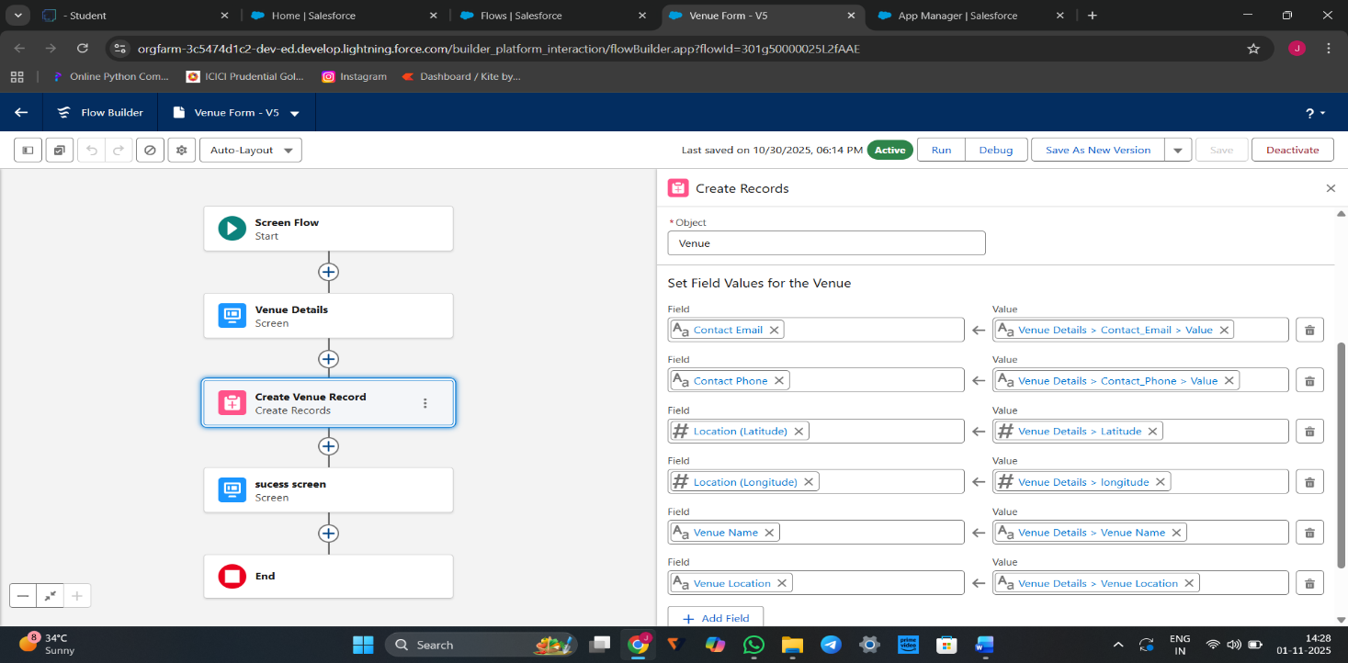

# Create a Trigger

1. Log into the trailhead account, navigate to the gear icon in the top right corner.
2. Click on developer console and you will be navigated to a new console window.
3. Click on the File menu in the toolbar, and click on new >> Trigger.
4. Enter the trigger name and the object to be triggered.

5.Enter Name : DropOffTriggersObject: Drop-Off Point

6.Click on Submit.

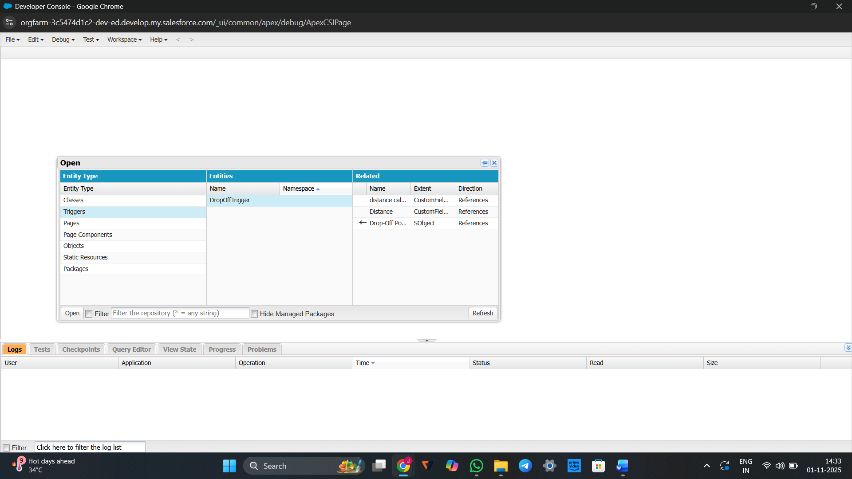

Profiles

1. Go to setup page >> type Profiles in Quick Find bar >> click on Profiles >> click on ‘S’
2. Click on Clone beside Standard Platform User.
3. Under Clone Profile:

Profile Name : NGOs Profile

4.Then click on Save

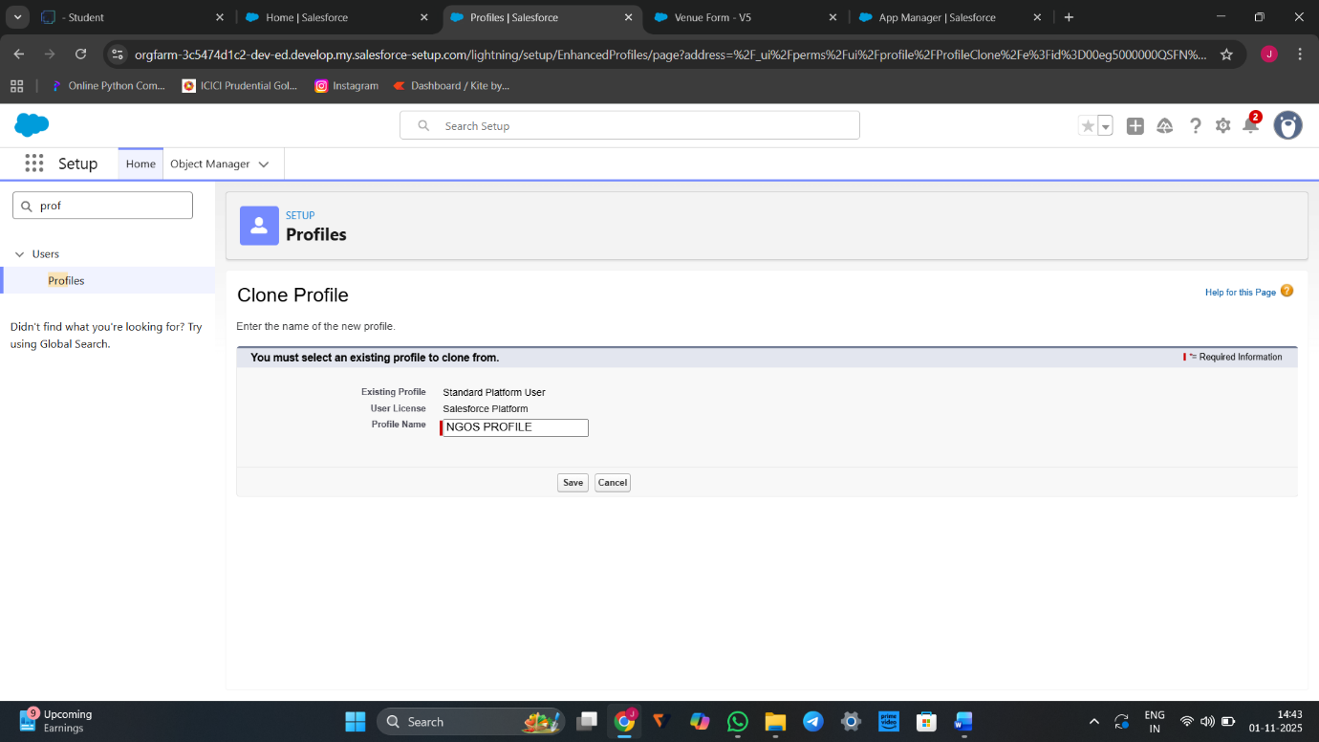

# Creation of Users

## Creation of User1

1. Go to setup page >> type users in Quick Find bar >> click on users>> New user.
2. In General Information give details as: (Note : create users as per your wish NGO’s)

First Name : Iksha Foundation

Last Name : Iksha_Foundation

Alias : iiksh

Email : Give Your Email

Username : [ikshafoundation@sb.com](mailto:ikshafoundation@sb.com) (give the username different)

Nickname : Auto Populated

User License : Salesforce Platform

Profile : NGOs Profile

Active : Check

3.Click on save

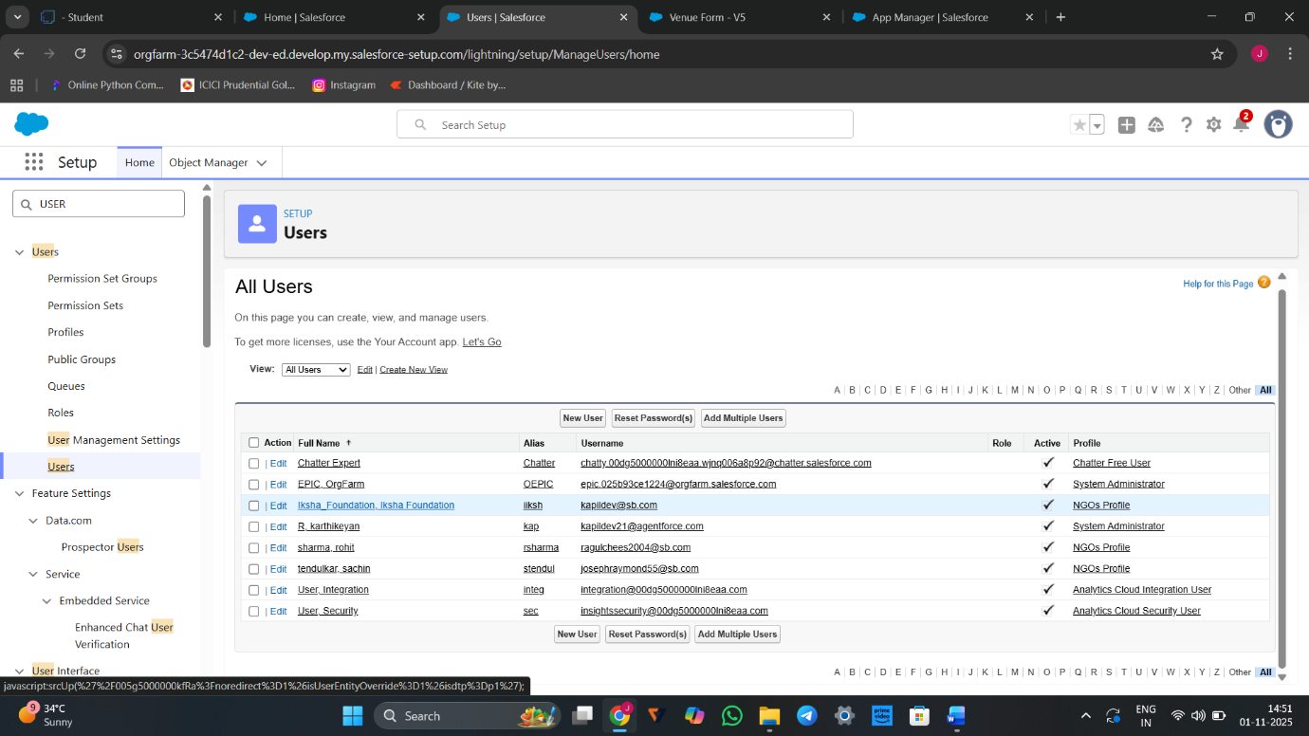

# Public Groups

# Creation of Public Group

1. Go to setup page  >>  type Public Groups in Quick Find bar  >>  click on Public Groups >>  click on New.
2. Under Group Information:

Label : Iksha

Group Name : Iksha

Grant Access Using Hierarchies : Check

3.In Search, Select Users.

4.In Selected Members Add Iksha Foundation and System Administrator

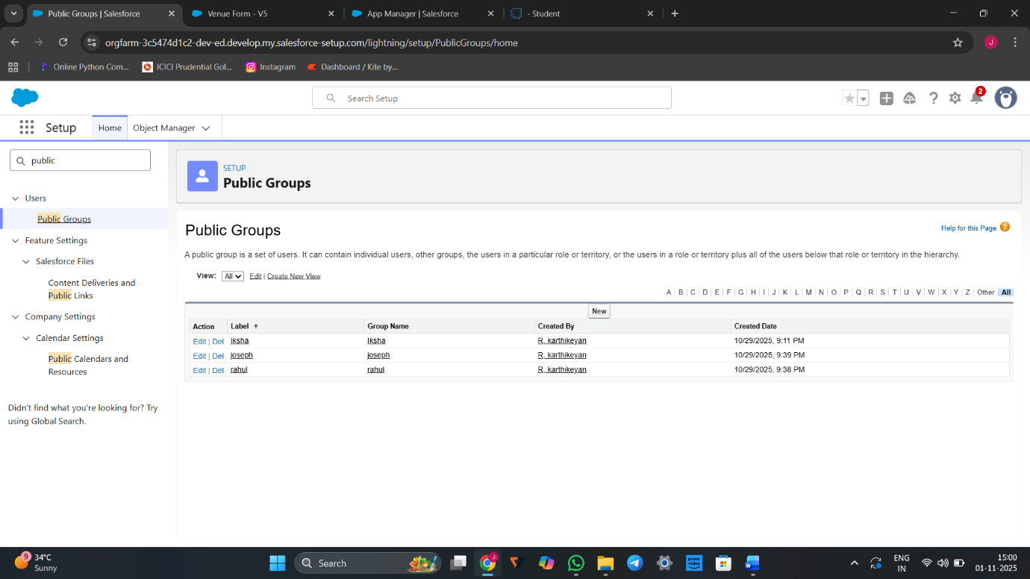

# Report Types

## Creation of Report Types

1. Go to setup page  >>  type Report Types in Quick Find bar  >> click on Report Types  >>  click on Continue   >>  Click on New Custom Report Type.
2. In Define the Custom Report Type:

Primary Object : Select Venues

Report Type Label : Venue with DropOff with Volunteer

Report Type Name : Venue_with_DropOff_with_Volunteer

Description : Venue with DropOff with Volunteer

Store in Category : Select Other Reports

Deployment Status : Deployed

3.Click on Next

4.Near Click to relate another Object Select Drop-Off Points.

5.And also select "A" records may or may not have related "B" records.

6.Now again Near Click to relate another Object Select Volunteers.

7.Now click on Save.

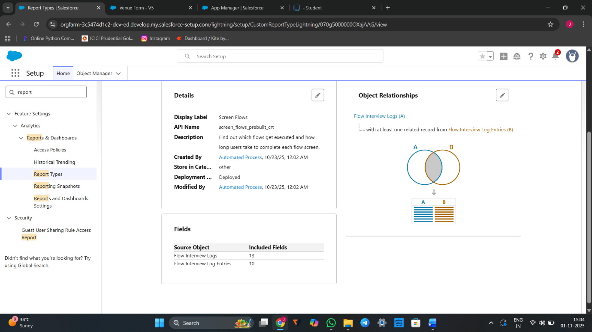

# Reports

## Creation of Report on Venue with DropOff with Volunteer

1. Go to the app(FoodConnect)  >>  click on the reports tab
2. Click on New Folder.

Folder Label : Custom Reports

Folder Unique Name : CustomReports

1. Open Custom Reports and click on New Report
2. Select Report Type : Venue with DropOff with Volunteer
3. Then click on Start Report.
4. In GROUP ROWS : Add Volunteer Name
5. In Columns : Add Venue Name, Drop-Off point Name, Distance.
6. Give Label as :
7. Report Name : venue and Drop Off point
8. Report Unique Name : Auto Populated
9. Click on Select Folder and select Custom Report, then click on Save.
10. Now click on Save & Run.

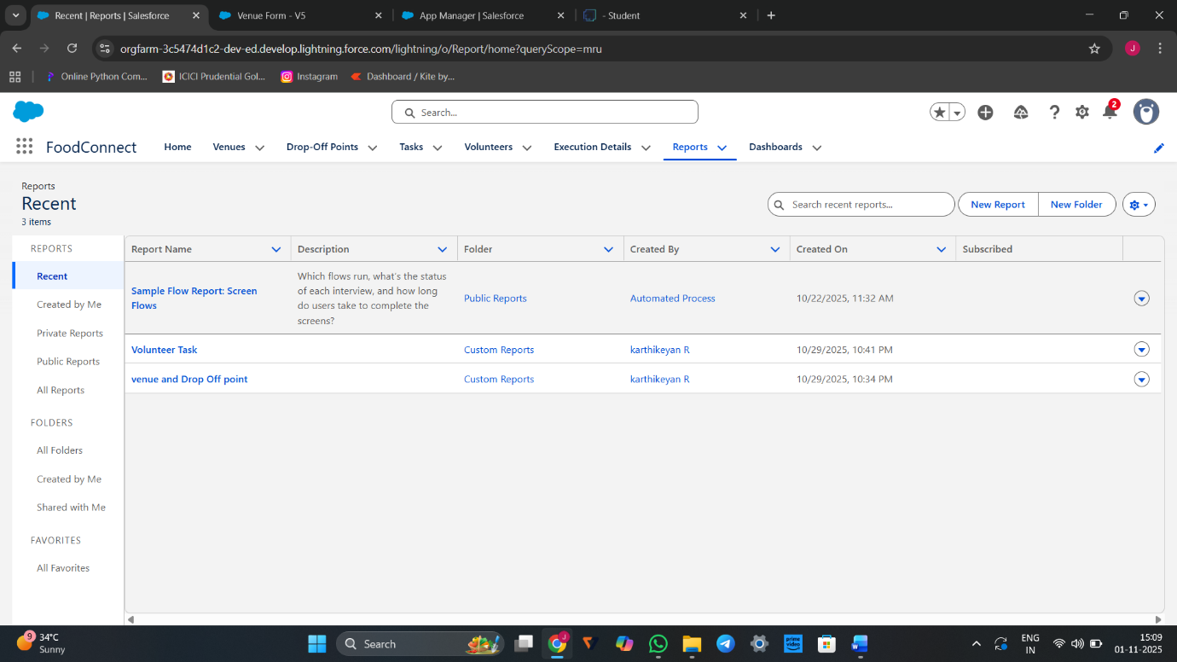

### Dashboards

**Adding venue and Drop Off point Report to the Dashboard**

1. Go to the app(FoodConnect)  >>  click on the Dashboards tab.
2. Click on New Folder.

Folder Label : Custom Dashboards

Folder Unique Name : Auto Populated

1. Open Custom Dashboards and click on New Dashboards
2. Name : Organization Details
3. Click on Widget and select Chart or Table
4. In Select Report : Select venue and Drop Off point Report.
5. Then click on select
6. In Add Component:

Display As : Select Lightning Table

Component Theme : Select Dark (Optional)

9.Now click on save.

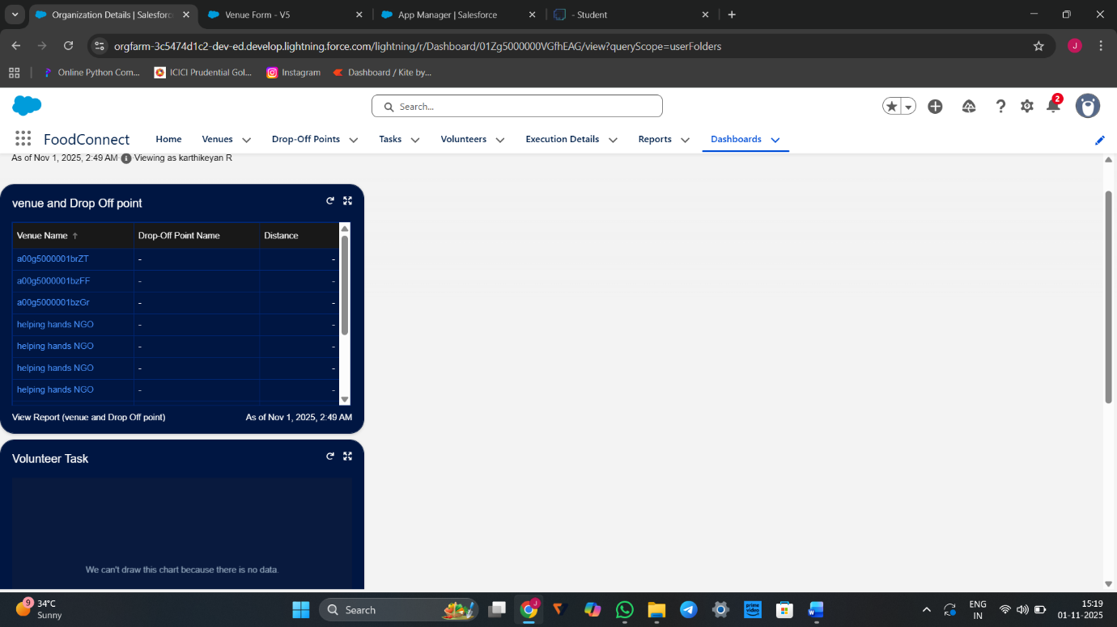

**Adding Volunteer Task Report to the Dashboard**

1. Click on Widget and select Chart or Table
2. In Select Report : Select Volunteer Task Report.
3. Then click on select
4. In Add Component:

Display As : Select Line Chart

Component Theme : Select Dark (Optional)

5.Now click on save. 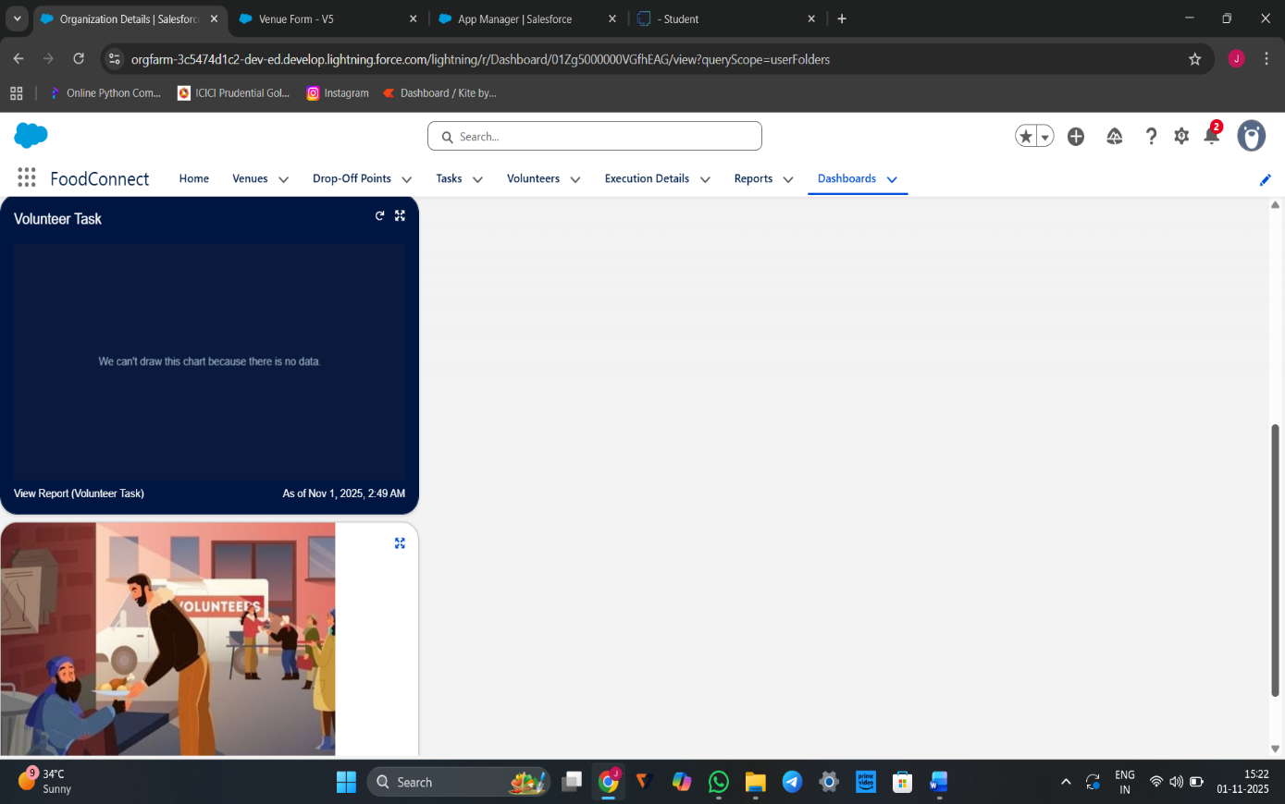

# Sharing Rules

## Creation of sharing rules

1. Go to setup  >>  type Sharing Settings in quick find box  >>  Click on the Sharing Settings.
2. Scroll down and find Drop-Off point Sharing Rules.
3. Click on new near Drop-Off point Sharing Rules and Name it as:

Label : Rule 1

Rule Name : Rule_1

1. Select your rule type : Select Based on criteria.
2. Select which records to be shared:

Field : Operator : Value = Distance : less than : 15

1. Select the users to share with : Near Share With

Public Groups : Iksha

1. Click on Save.
2. Click on new near Drop-Off point Sharing Rules and Name it as:

Label : Rule 2

Rule Name : Rule_2

1. Select your rule type : Select Based on criteria.
2. Select which records to be shared:

Field : Operator : Value = Distance : greater than : 15

Field : Operator : Value = Distance : less or equal : 30

1. Select the users to share with : Near Share With

Public Groups : NSS

1. Click on Save.
2. Click on new near Drop-Off point Sharing Rules and Name it as:

Label : Rule 3

Rule Name : Rule_3

1. Select your rule type : Select Based on criteria.
2. Select which records to be shared:

Field : Operator : Value = Distance : greater than : 30

Field : Operator : Value = Distance : less or equal : 50

1. Select the users to share with : Near Share With

Public Groups : Street Cause

1. Click on Save.

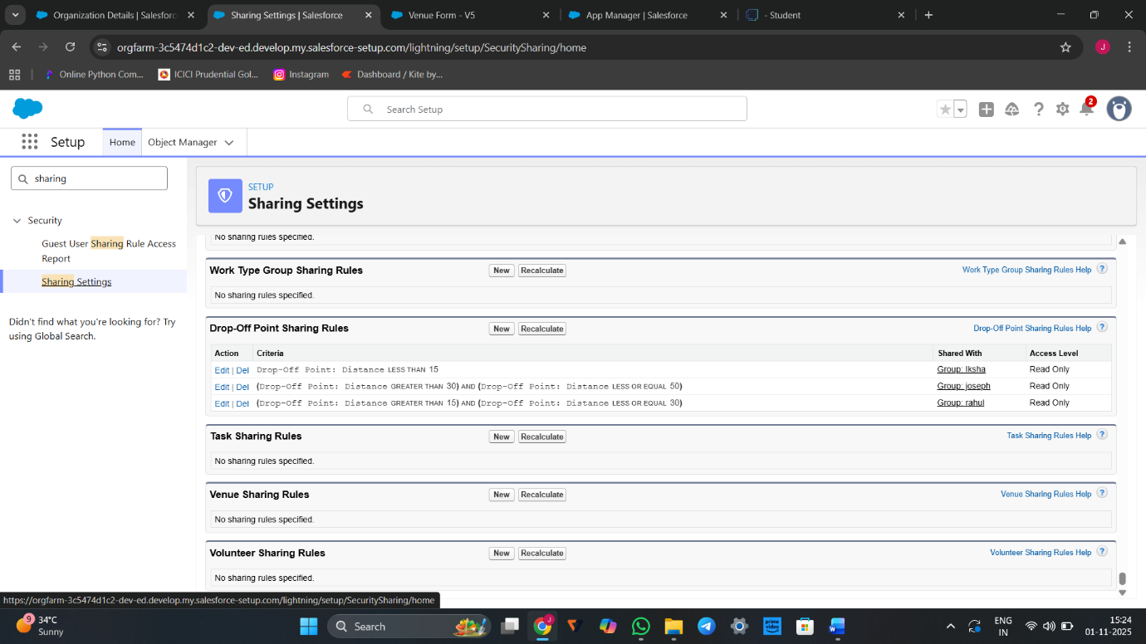

# Home Page

## Creation of Home Page

1. Go to setup >> type Lightning App Builder in quick find box  >>  Click on the Lightning App Builder and Select the New.
2. Select Home Page and give Label as HOME Page.
3. Select Standard Home Page.
4. Near Components search for Flow and Drag and Drop in Right Side Section..
5. On the right hand side:

Flow : Venue Flow

1. Near Components search for Dashboard, then Drag and Drop it in first Section.

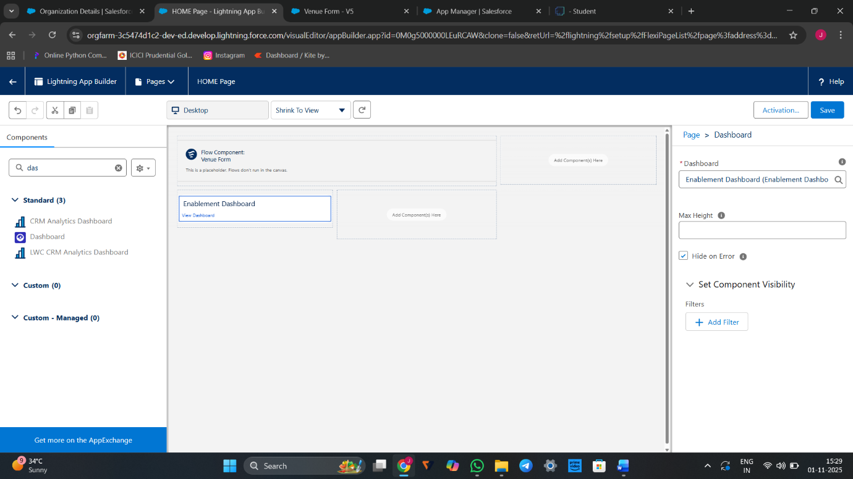

# *Conclusion*

By leveraging the Salesforce platform, the project successfully established a streamlined and transparent system for managing surplus food donations. Through efficient coordination with volunteers and timely delivery to beneficiaries, the project effectively addressed food insecurity while maximizing the utilization of available resources.